**ORACLE 12R2 INSTALLATION ON AWS EC2 INSTANCE:**

1. **Download Software**

Download the Oracle software from OTN or MOS depending on your support status.

* [OTN: Oracle Database 12c Release 2 (12.2.0.1) Software (64-bit).](http://www.oracle.com/technetwork/database/enterprise-edition/downloads/index.html)

=== Downlaod the Software directly to the server, first install the wget package

yum install wget zip unzip -y

yum update -y

* [root@ip-172-31-32-90 tmp]# wget <https://download.oracle.com/otn/linux/oracle12c/122010/linuxx64_12201_database.zip?AuthParam=1559227517_76d9b6023c9b3dddae5aba09833ceed0>
* [oracle@ip-172-31-32-90 tmp]$ unzip linuxx64_12201_database.zip?AuthParam=1559227517_76d9b6023c9b3dddae5aba09833ceed0

1. **Add the following lines to the "/etc/sysctl.conf" file, or in a file called "/etc/sysctl.d/98-oracle.conf".**

fs.file-max = 6815744

kernel.sem = 250 32000 100 128

kernel.shmmni = 4096

kernel.shmall = 1073741824

kernel.shmmax = 4398046511104

kernel.panic_on_oops = 1

net.core.rmem_default = 262144

net.core.rmem_max = 4194304

net.core.wmem_default = 262144

net.core.wmem_max = 1048576

net.ipv4.conf.all.rp_filter = 2

net.ipv4.conf.default.rp_filter = 2

fs.aio-max-nr = 1048576

net.ipv4.ip_local_port_range = 9000 65500

1. **Run one of the following commands to change the current kernel parameters, depending on which file you edited.**

* /sbin/sysctl -p

1. Install the following packages

yum install binutils -y

yum install compat-libcap1 -y

yum install compat-libstdc++-33 -y

yum install compat-libstdc++-33.i686 -y

yum install glibc -y

yum install glibc.i686 -y

yum install glibc-devel -y

yum install glibc-devel.i686 -y

yum install ksh -y

yum install libaio -y

yum install libaio.i686 -y

yum install libaio-devel -y

yum install libaio-devel.i686 -y

yum install libX11 -y

yum install libX11.i686 -y

yum install libXau -y

yum install libXau.i686 -y

yum install libXi -y

yum install libXi.i686 -y

yum install libXtst -y

yum install libXtst.i686 -y

yum install libgcc -y

yum install libgcc.i686 -y

yum install libstdc++ -y

yum install libstdc++.i686 -y

yum install libstdc++-devel -y

yum install libstdc++-devel.i686 -y

yum install libxcb -y

yum install libxcb.i686 -y

yum install make -y

yum install nfs-utils -y

yum install net-tools -y

yum install smartmontools -y

yum install sysstat -y

yum install unixODBC -y

yum install unixODBC-devel -y

yum install gcc -y

yum install gcc-c++ -y

yum install libXext -y

yum install libXext.i686 -y

yum install zlib-devel -y

yum install zlib-devel.i686 -y

dnf install -y libnsl2.i686

xclock packages

yum install xauth

sudo yum install -y gcc-c++

sudo yum install -y libX11-devel

sudo yum install -y fontconfig-devel

sudo yum install -y libXcursor-devel

sudo yum install -y libXext-devel

sudo yum install -y libXfixes

sudo yum install -y libXft-devel

sudo yum install -y libXi-devel

sudo yum install -y libXrandr-devel

sudo yum install -y libXrender-devel

yum install xorg-x11-xauth.x86_64 xorg-x11-server-utils.x86_64 dbus-x11.x86_64

yum install xorg-x11-fonts* -y

yum install xorg-x11-server-Xorg.x86_64

yum install xdpyinfo

**ERROR:**

[INS-10102] Installer initialization failed.

Cause - An unexpected error occurred while initializing the Installer.

Action - Contact Oracle Support Services or refer logs Summary

 - [INS-10012] Setup driver initialization failed.

- no oraInstaller in java.library.path

**SOLUTION:**

dnf install libnsl

1. **Create the new groups and users.**

groupadd -g 54321 oinstall

groupadd -g 54322 dba

groupadd -g 54323 oper

useradd -u 54321 -g oinstall -G dba,oper oracle

passwd oracle

1. **Create the directories in which the Oracle software will be installed**.

mkdir -p /u01/app/oracle/product/12.2.0.1/db_1

chown -R oracle:oinstall /u01

chmod -R 775 /u01

Change directory ownership from root to oracle

**[root@ip-172-31-32-90 tmp]# chown -R oracle:oinstall /tmp**

**[root@ip-172-31-32-90 tmp]# chown -R oracle:oinstall /u01**

**[root@ip-172-31-32-90 tmp]# chown -R oracle:oinstall /u02**

**[root@ip-172-31-32-90 tmp]# chown -R oracle:oinstall /u03**

1. **Additional step turn on swap**

[root@ip-172-31-32-90 tmp]# free m

total used free shared buff/cache available

Mem: 7999040 239380 138888 24988 7620772 7469060

Swap: 0 0 0

[root@ip-172-31-32-90 /]# mkdir -p /swapfile1

[root@ip-172-31-32-90 /]# mount /dev/xvdb /swapfile1

[root@ip-172-31-32-90 /]# dd if=/dev/zero of=/swapfile1/swapfile bs=1024 count=3145728

3145728+0 records in

3145728+0 records out

3221225472 bytes (3.2 GB, 3.0 GiB) copied, 11.8207 s, 273 MB/s

[root@ip-172-31-32-90 /]# chown root:root /swapfile1/swapfile

[root@ip-172-31-32-90 /]# chmod 0600 /swapfile1/swapfile

[root@ip-172-31-32-90 /]# mkswap /swapfile1/swapfile

Setting up swapspace version 1, size = 3 GiB (3221221376 bytes)

no label, UUID=389abd7e-d2e5-45aa-966d-9618901dcd6a

[root@ip-172-31-32-90 /]# swapon /swapfile1/swapfile

[root@ip-172-31-32-90 /]# free -m

total used free shared buff/cache available

Mem: 7811 236 138 24 7436 7288

Swap: 3071 0 3071

1. **Set up the environment for the oracle user**

[oracle@ip-172-31-32-90 ~]$ pwd

/home/oracle

[oracle@ip-172-31-32-90 ~]$ ll -a

total 24

drwx------. 2 oracle oinstall 116 May 30 15:54 .

drwxr-xr-x. 5 root root 49 May 30 15:33 ..

-rw-------. 1 oracle oinstall 148 May 30 16:00 .bash_history

-rw-r--r--. 1 oracle oinstall 18 Jan 14 06:10 .bash_logout

-rw-r--r--. 1 oracle oinstall 141 Jan 14 06:10 .bash_profile

-rw-r--r--. 1 oracle oinstall 312 Jan 14 06:10 .bashrc

-rw-r--r--. 1 oracle oinstall 172 Oct 16 2018 .kshrc

-rw-------. 1 oracle oinstall 88 May 30 15:54 .Xauthority

[oracle@ip-172-31-32-90 ~]$ vi .bash_profile

[oracle@ip-172-31-32-90 ~]$ source .bash_profile

[oracle@ip-172-31-32-90 ~]$

[oracle@ip-172-31-32-90 ~]$ cat .bash_profile

# .bash_profile

# Get the aliases and functions

if [ -f ~/.bashrc ]; then

. ~/.bashrc

fi

# User specific environment and startup programs

umask 022

TMP=/tmp; export TMP

TMPDIR=$TMP; export TMPDIR

ORACLE_HOSTNAME=localhost.localdomain; export ORACLE_HOSTNAME

ORACLE_BASE=/u01/app/oracle; export ORACLE_BASE

ORACLE_HOME=/u01/app/oracle/product/12.2.0.1/db_1; export ORACLE_HOME

ORACLE_SID=orclsqa; export ORACLE_SID

ORACLE_TERM=xterm; export ORACLE_TERM

PATH=$ORACLE_HOME/bin:/usr/sbin:$PATH; export PATH

LD_LIBRARY_PATH=$ORACLE_HOME/lib:/lib:/usr/lib; export LD_LIBRARY_PATH

CLASSPATH=$ORACLE_HOME/JRE:$ORACLE_HOME/jlib:$ORACLE_HOME/rdbms/jlib; export CLASSPATH

1. **Setup the Xclock DISPLAY ENVIRONMENT**

[oracle@ip-172-31-32-90 ~]$ touch .Xauthority

[lagwe@ip-172-31-32-90 ~]$ ll -a

**-rw-------. 1 lagwe lagwe 88 May 30 15:48 .Xauthority**

[lagwe@ip-172-31-32-90 ~]$ echo $DISPLAY

**localhost:10.0**

[lagwe@ip-172-31-32-90 ~]$ xauth list $DISPLAY

**ip-172-31-32-90.us-east-2.compute.internal/unix:10 MIT-MAGIC-COOKIE-1 6c6fdcff758846fde8eac9911618d0a8**

[lagwe@ip-172-31-32-90 ~]$ sudo su – oracle

[oracle@ip-172-31-32-90 ~]$ xauth add ip-172-31-32-90.us-east-2.compute.internal/unix:10 MIT-MAGIC-COOKIE-1 6c6fdcff758846fde8eac9911618d0a

[oracle@ip-172-31-32-90 ~]$ echo $DISPLAY

[oracle@ip-172-31-32-90 ~]$ export DISPLAY=localhost:10.0

[oracle@ip-172-31-32-90 ~]$ echo $DISPLAY

localhost:10.0

[oracle@ip-172-31-32-90 ~]$ cd /tmp/database

[oracle@ip-172-31-32-90 database]$

[oracle@ip-172-31-32-90 database]$ ls -l

total 20

drwxr-xr-x. 4 oracle oinstall 234 Jan 26 2017 install

drwxrwxr-x. 2 oracle oinstall 61 Jan 26 2017 response

drwxr-xr-x. 2 oracle oinstall 35 Jan 26 2017 rpm

**-rwxr-xr-x. 1 oracle oinstall 8771 Jan 26 2017 runInstaller**

drwxrwxr-x. 2 oracle oinstall 29 Jan 26 2017 sshsetup

drwxr-xr-x. 14 oracle oinstall 4096 Jan 26 2017 stage

-rwxr-xr-x. 1 oracle oinstall 500 Feb 6 2013 welcome.html

1. **Installation**

[oracle@ip-172-31-32-90 database]$ ./runInstaller

Select and click Next to complete the installation.

And run the Root.sh scripts as ROOT user.

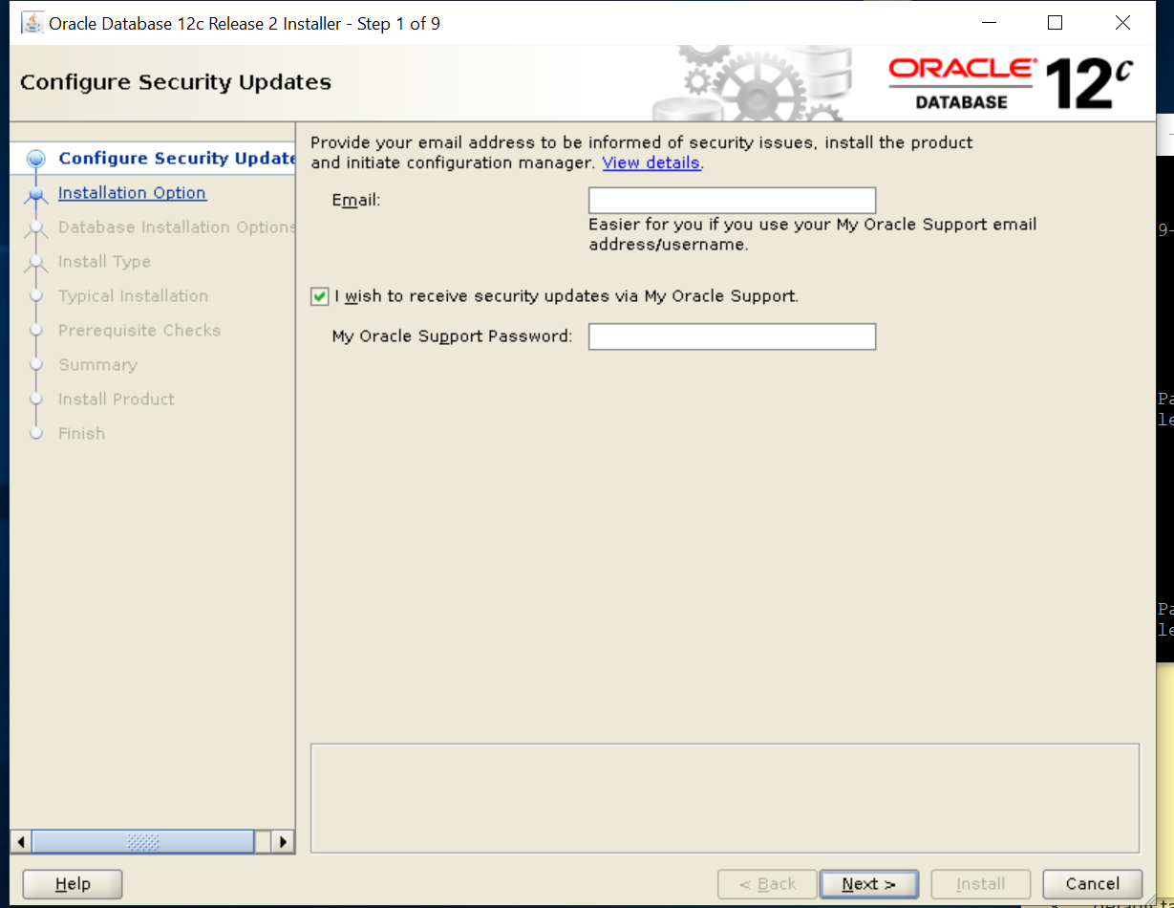

SELECT AND CLICK NEXT

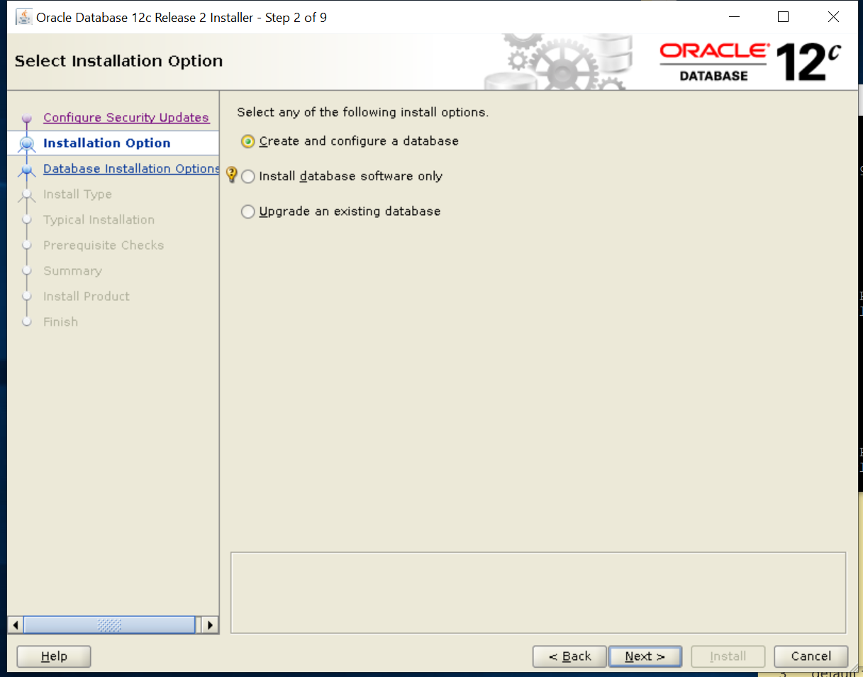

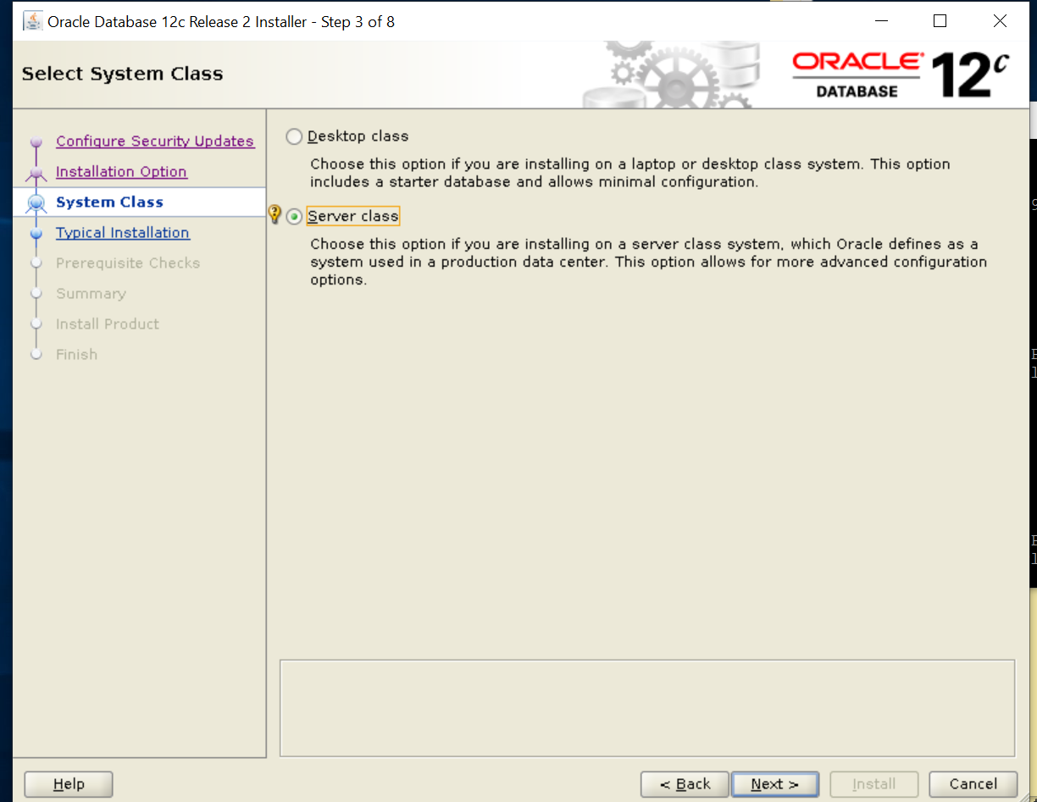

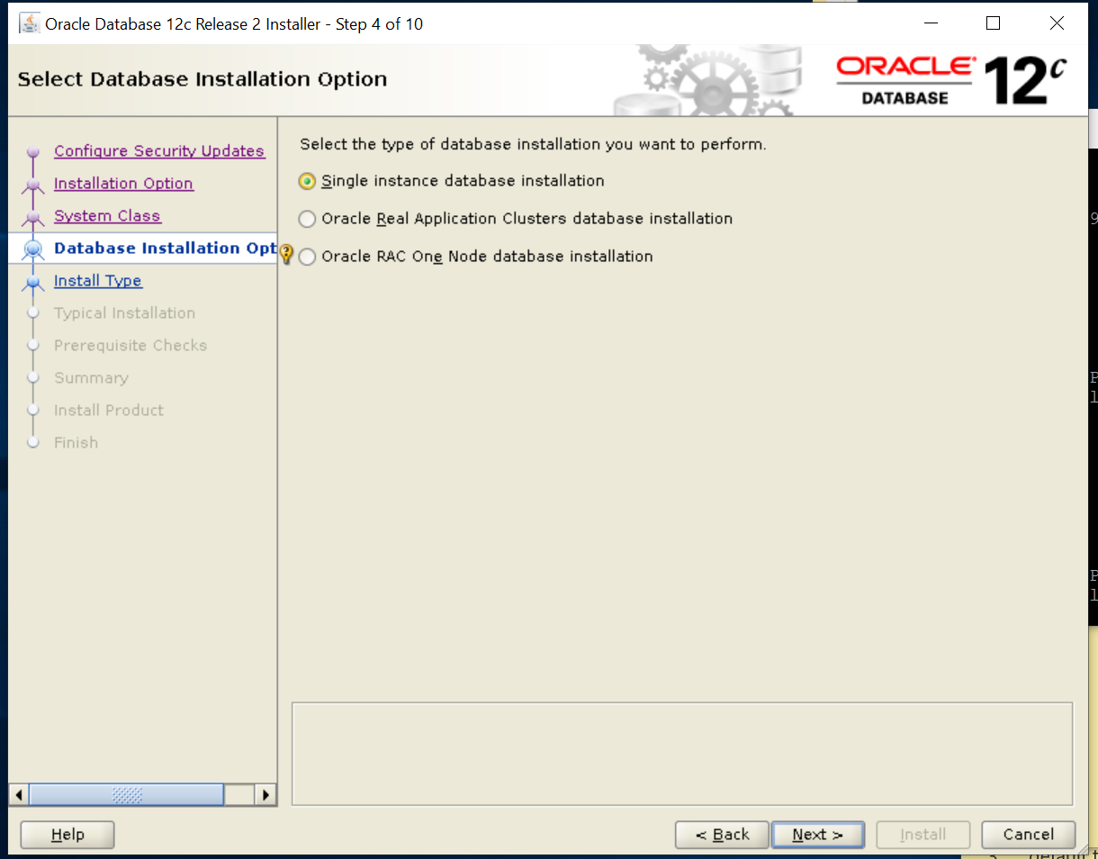

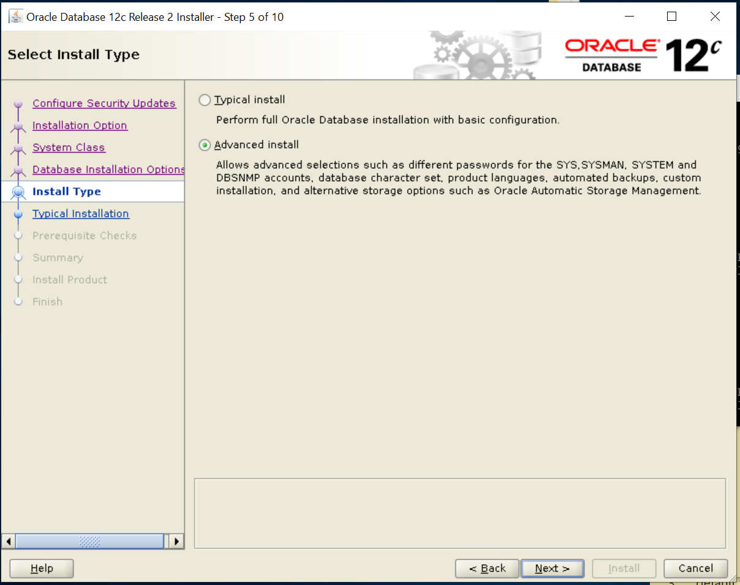

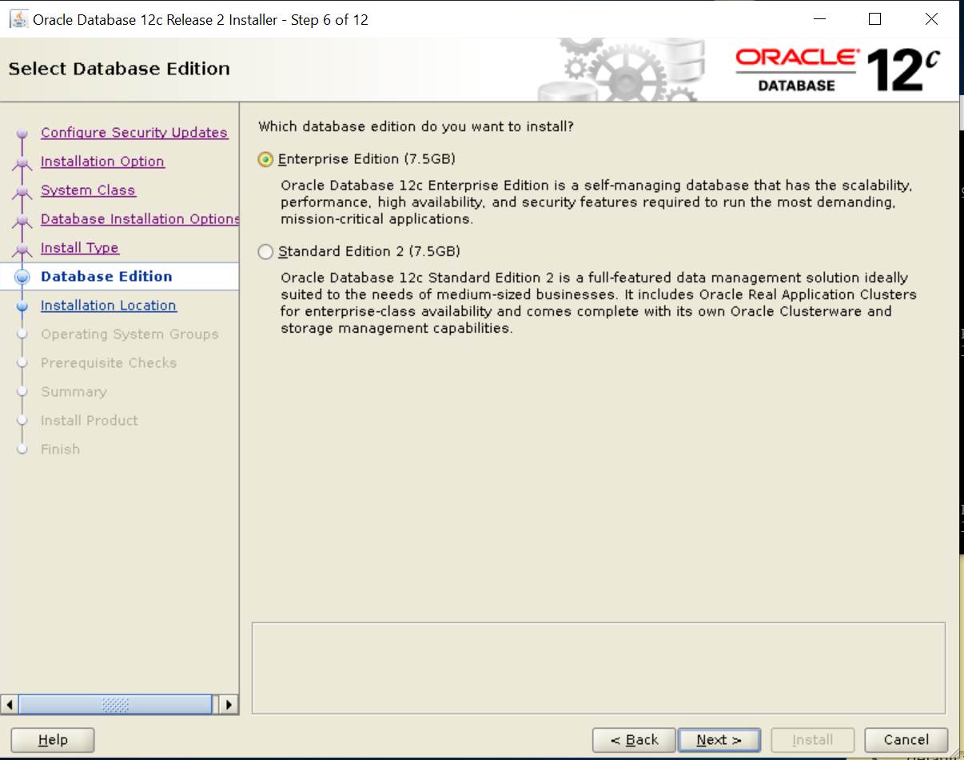

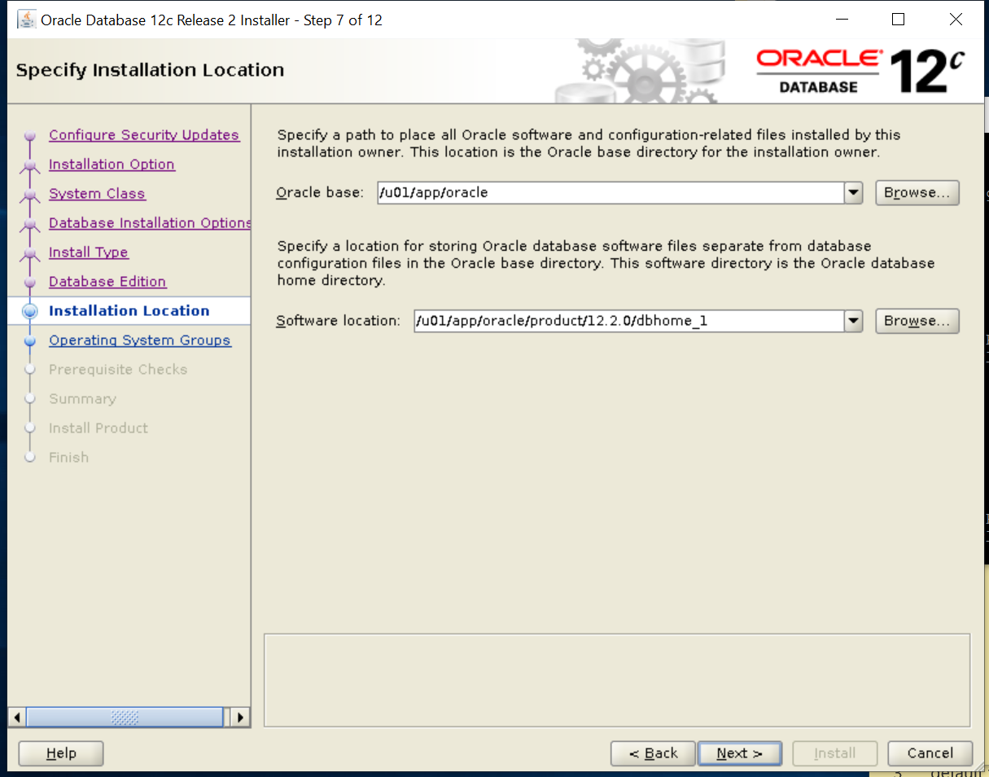

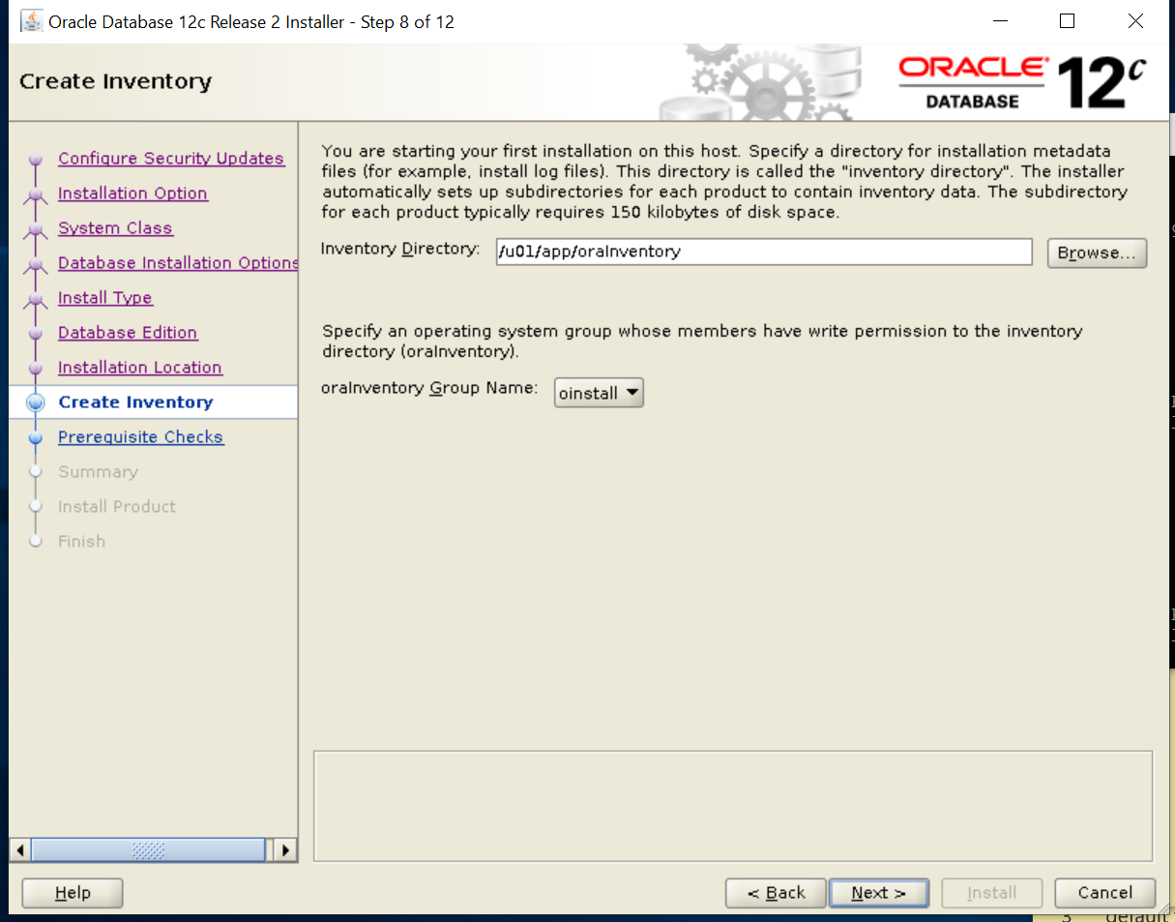

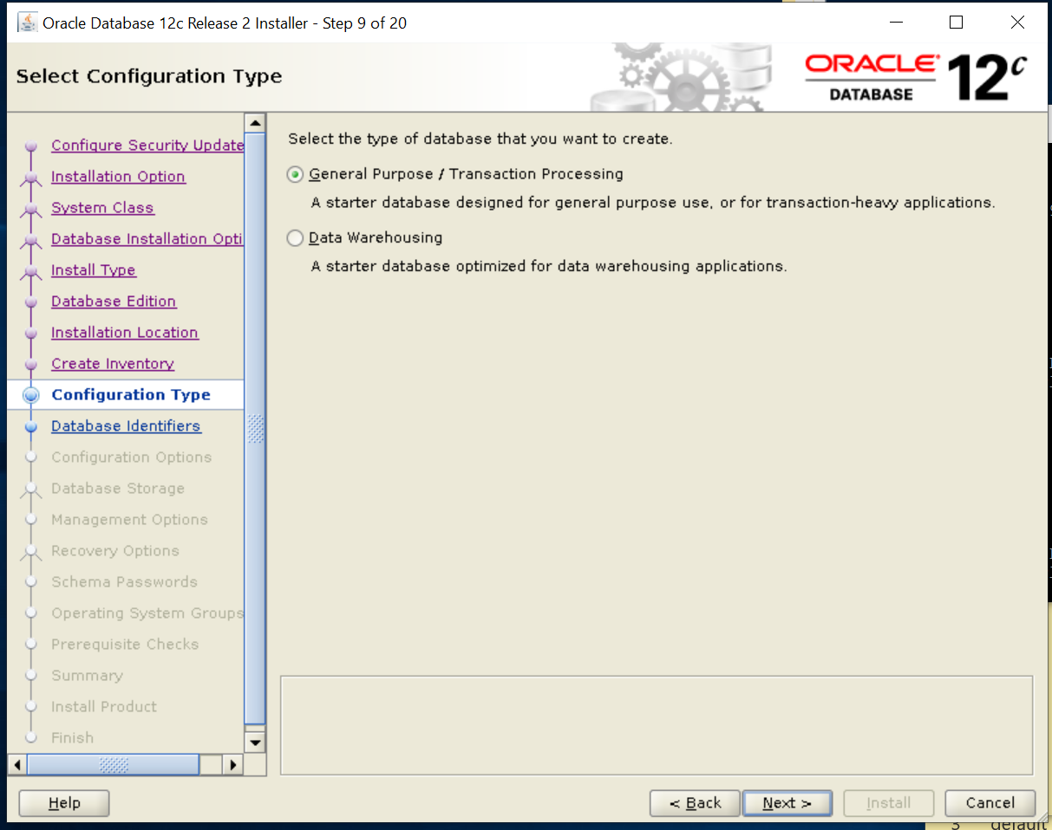

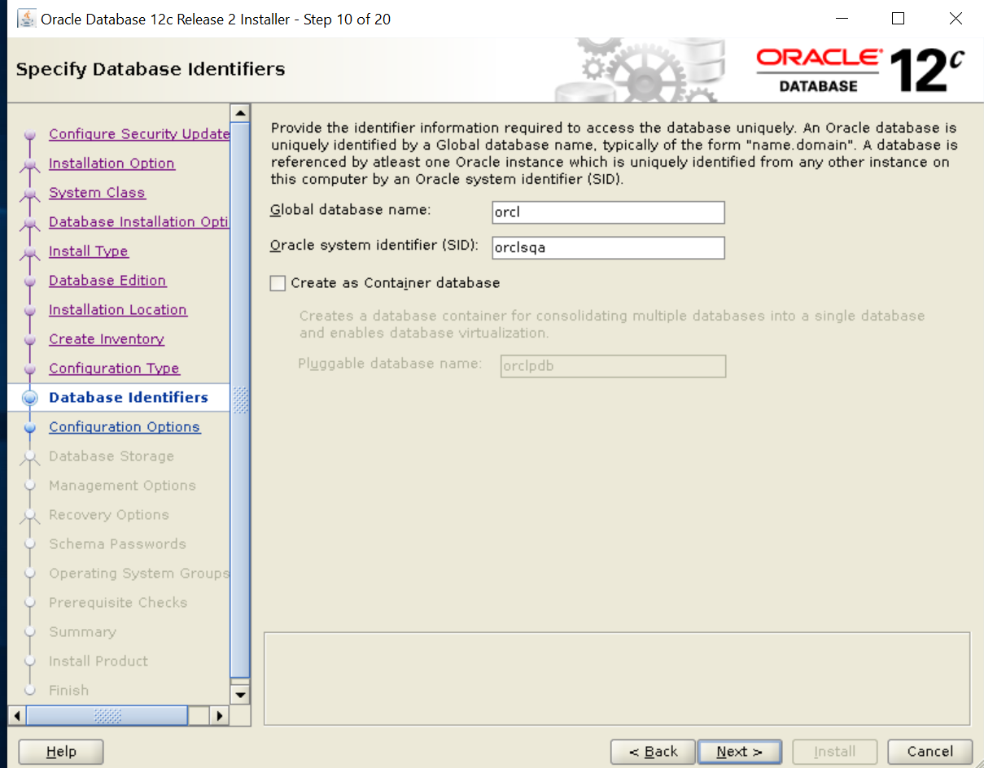

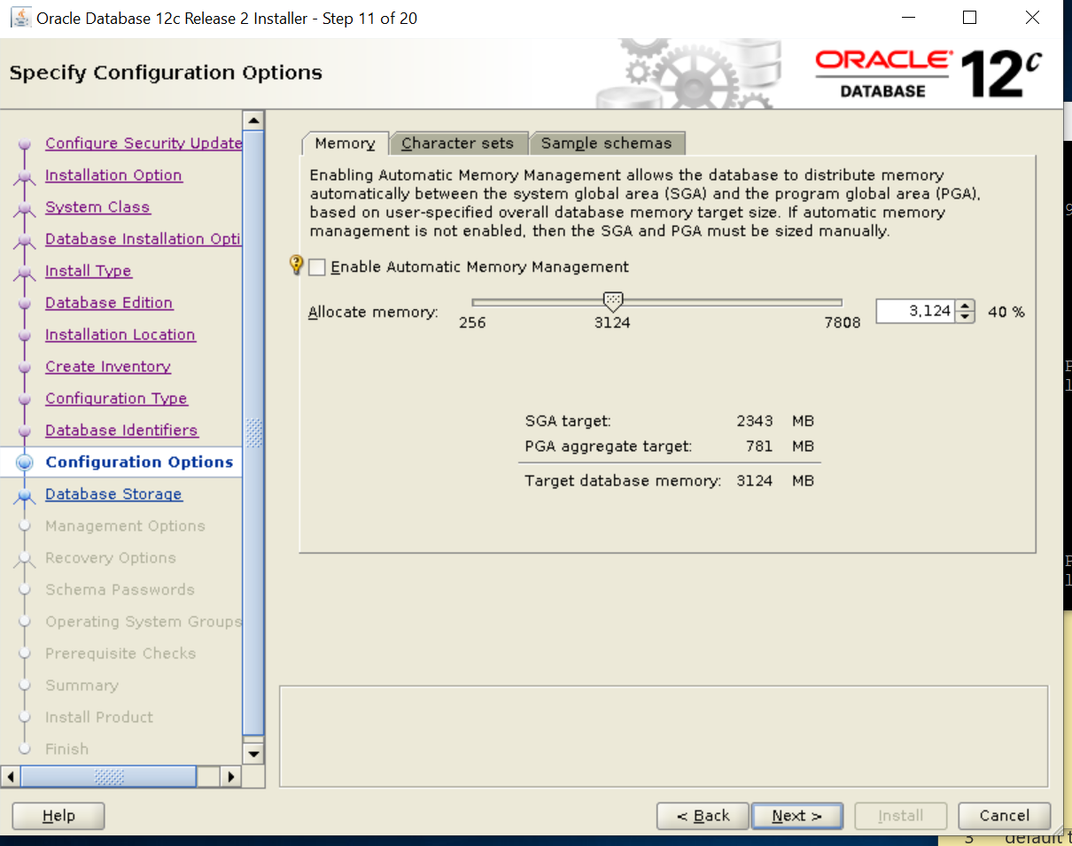

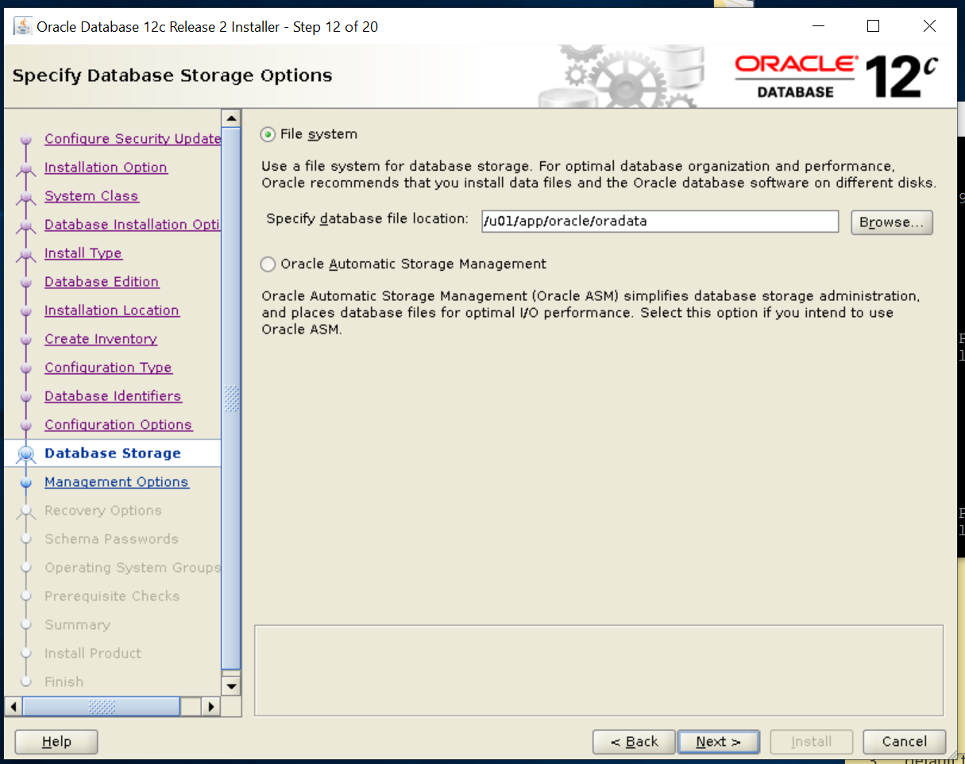

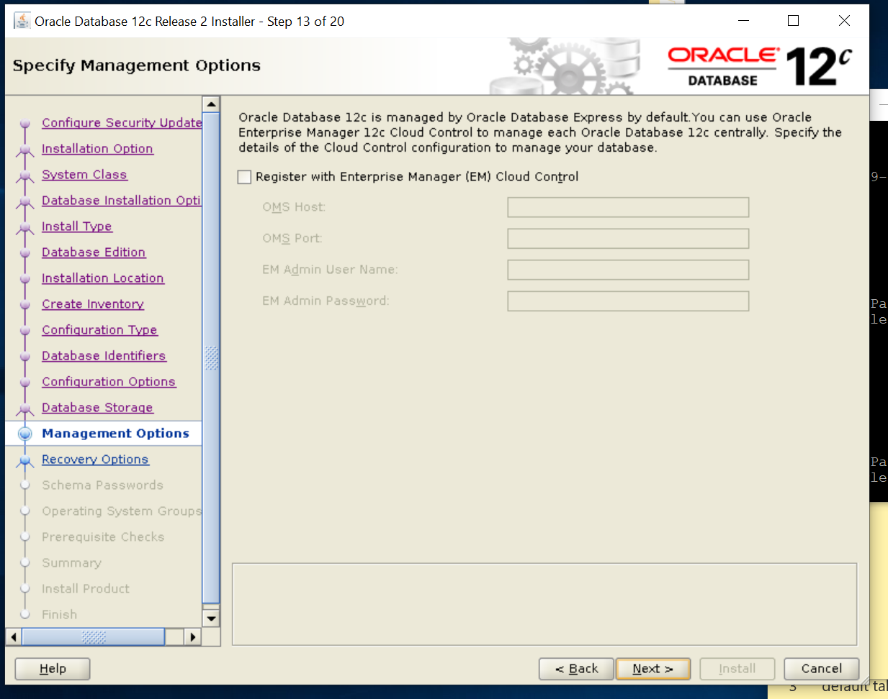

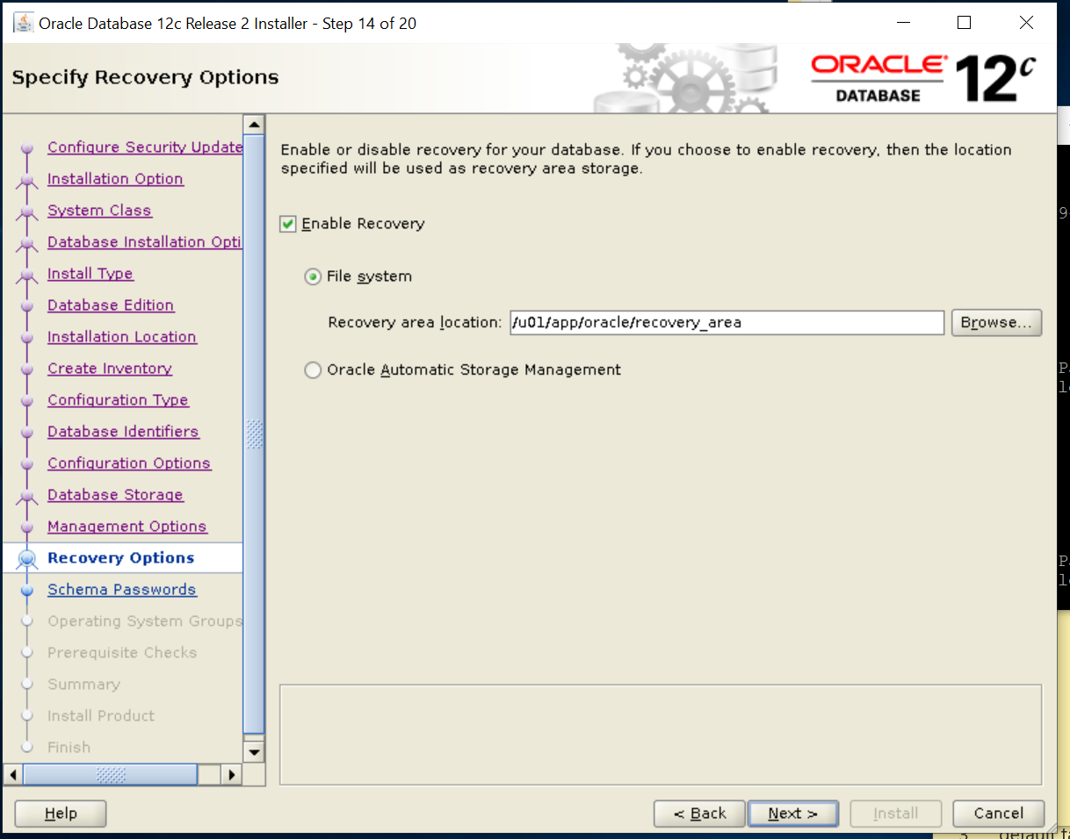

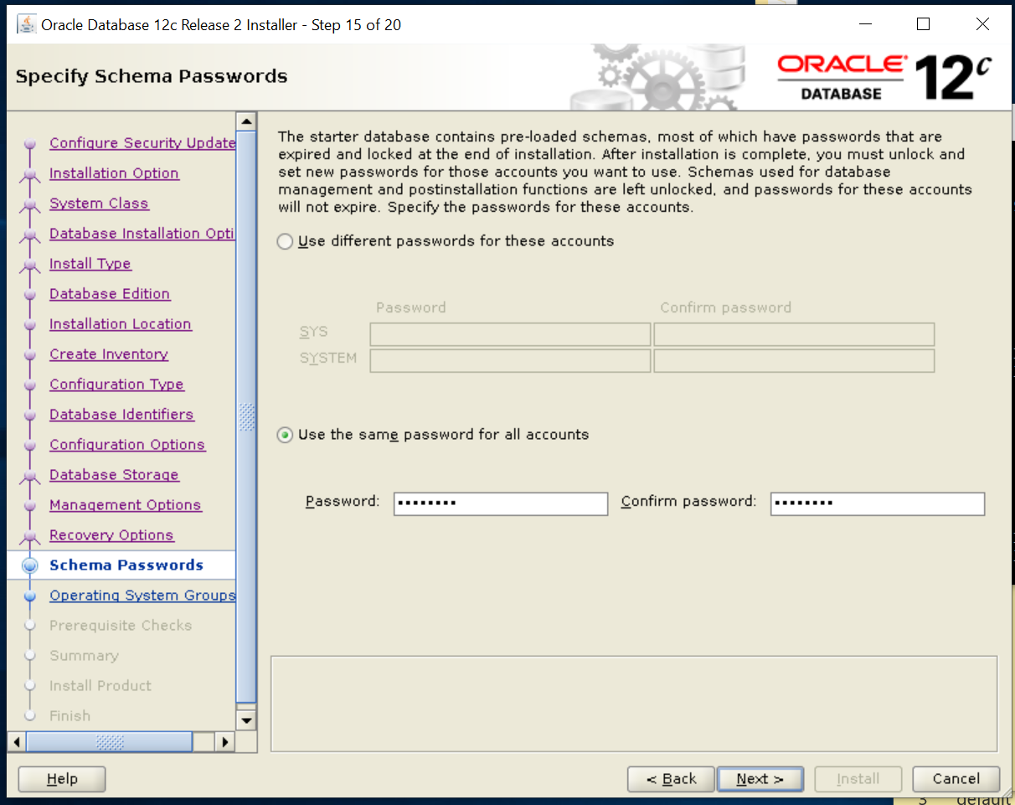

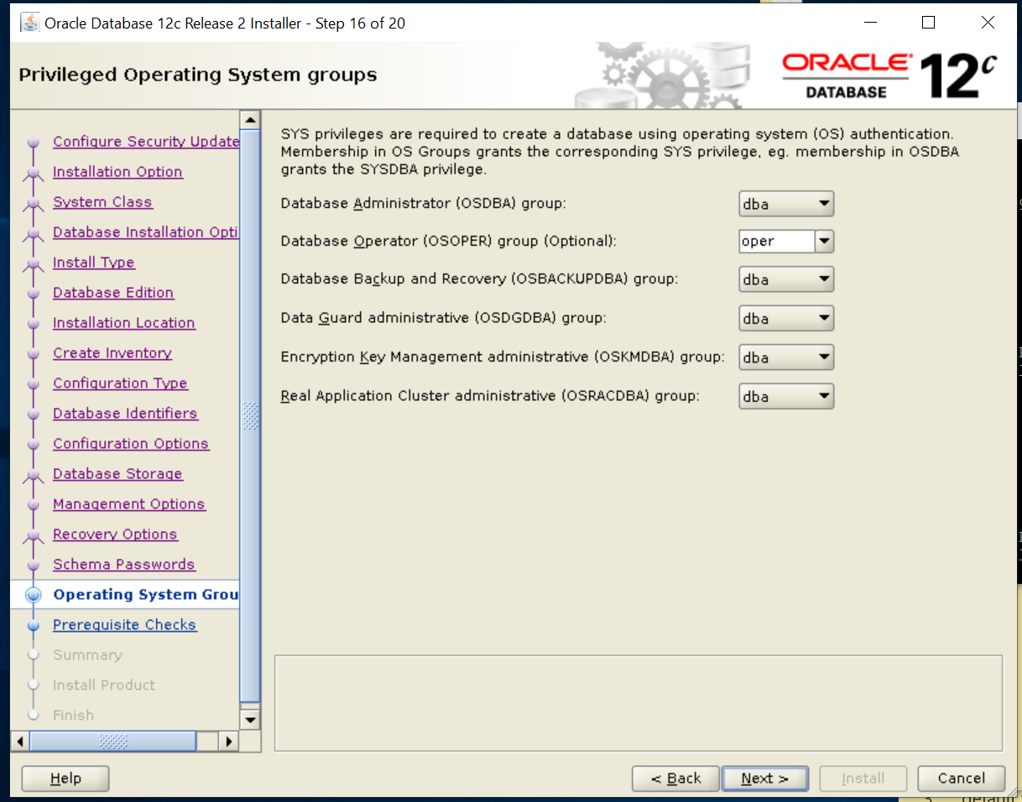

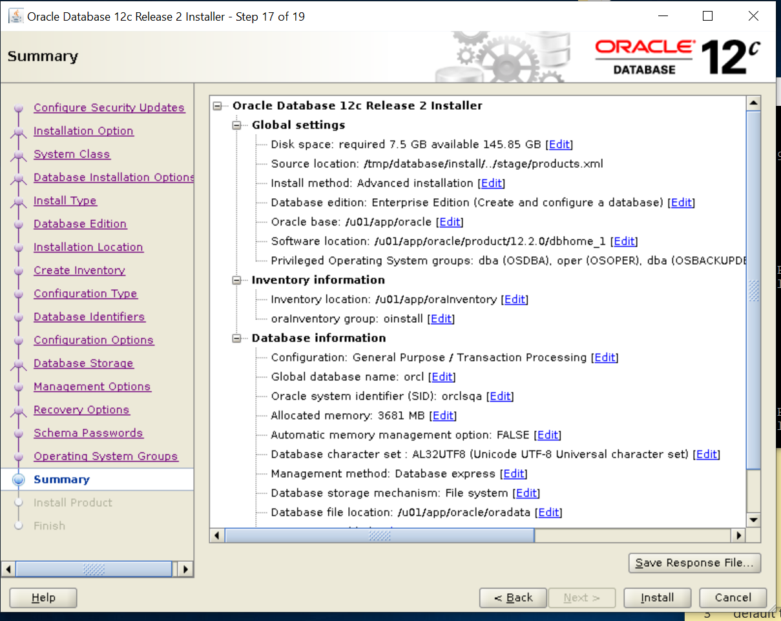

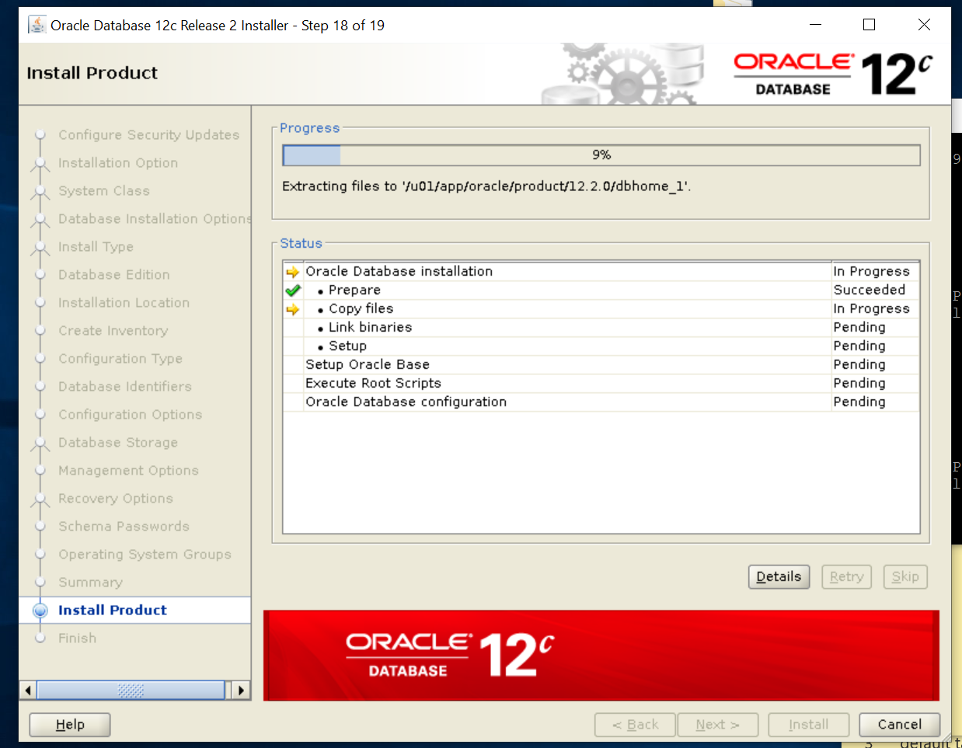

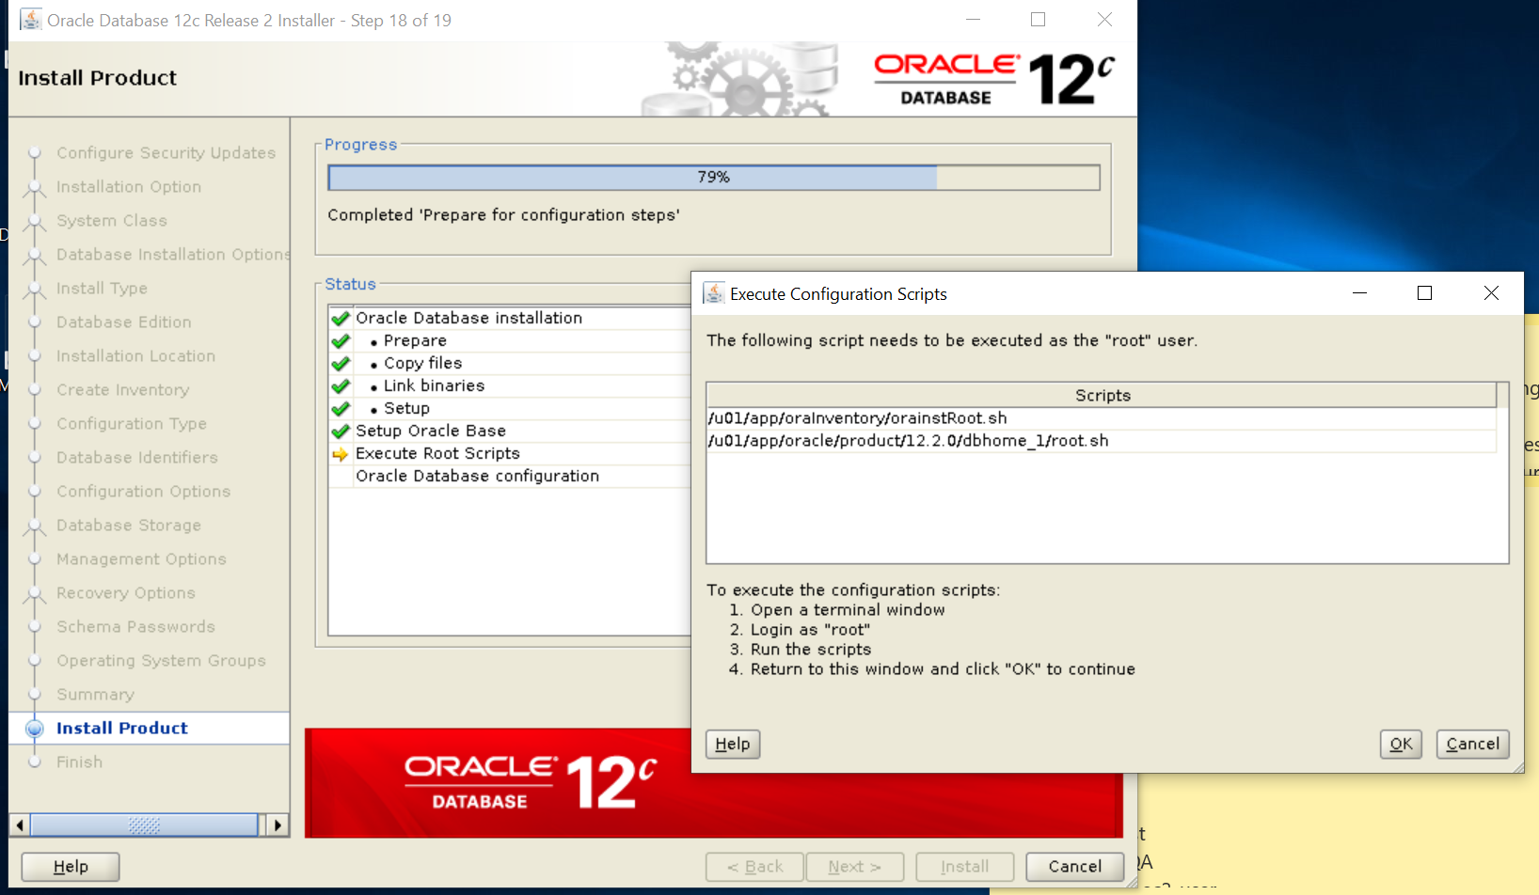

RUN SCRIPTS AND CLICK OK FOR THE INSTALLATION TO CONTINUE

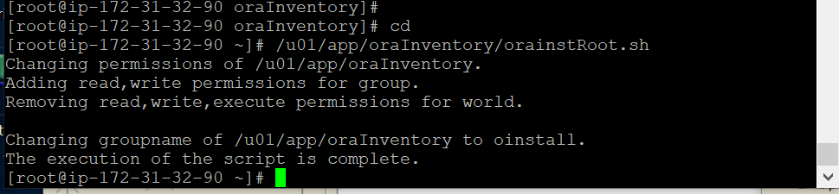

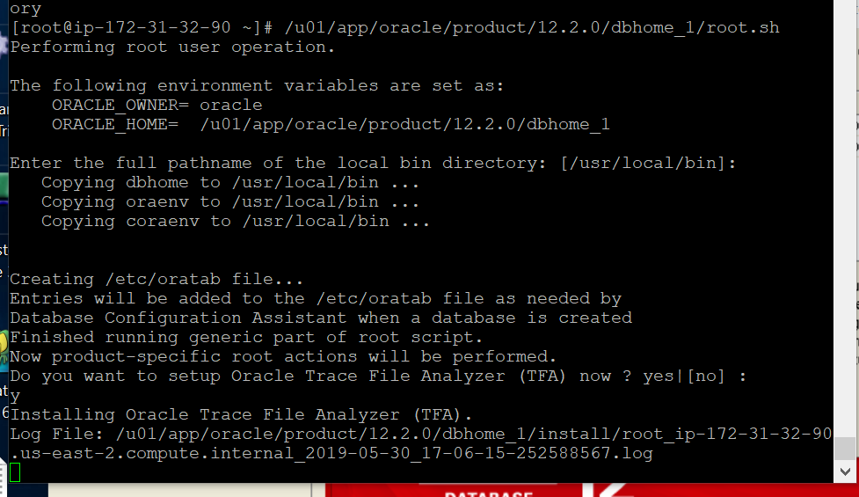

CLICK CLOSE AND THE SOFTWARE, DATABASE AND LISTENER HAS BEEN INSTALL.

